**Project Description**

**PROJECT ON INSTAGRAM ANALYTICS**

* Business insights are found that can be used by teams in the business to launch a new marketing campaign, discussing the features to build an application and track the application and its success by measuring user engagement

**Approach:**

**Creating Database:**

* Values are created and inserted in the database using DDL and DML SQL queries provided as per project in MYSQL database using MY SQL workbench

**Insights:**

* After the creation and insertion of database insights are generated from the database tables by running SQL Queries in MY SQL workbench

**Tech-Stack used:**

* MY SQL Community server-GPL Version 8.0.29 and connector version c++8.0.29 for creating my project as we know MY SQL community server is an open-source relational database management system that uses SQL

1. **MARKETING ANALYSIS:**
2. **Rewarding Most Loyal Users: People who have been using the platform for the longest time (TOP 5)**



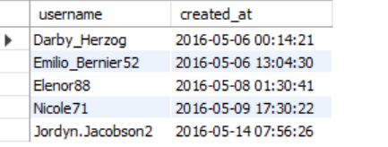

1. **Remind inactive users to start posting: By sending them promotional emails to post their First photo. The users who have never posted a single photo on Instagram**

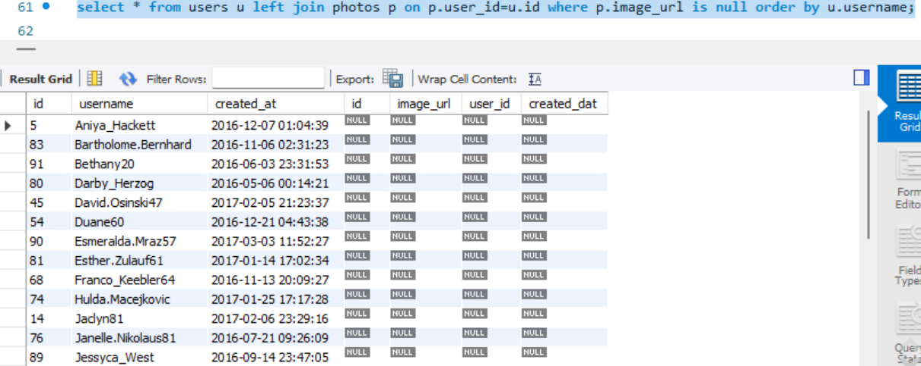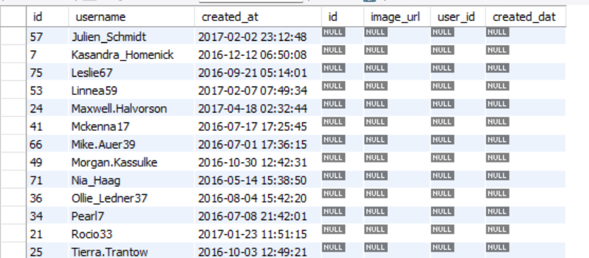

1. **Declaring Context winner: The team started a contest and the user who gets the most likes on a single photo will win the contest now they wish to declare the winner, Now I have to identify the winner of the contest and provide the details to the team**

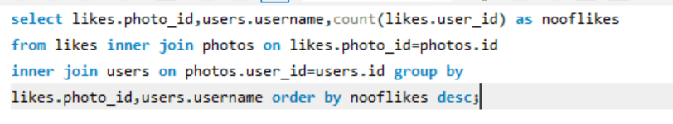



1. **Hashtag Research: This is to find out which hashtags have to be used to reach the most people on the platform. Now have to identify Top 5 most commonly used hashtags on the platform**

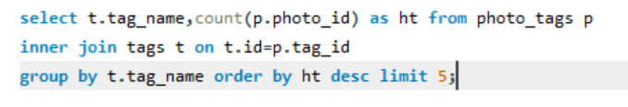

**The top 5 most commonly used hashtags on the platform**

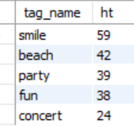

1. **Launch Ad Campaign: The team wants to know on which day it will be most suitable to launch the Advertisement campaigns. Now to find which day of the week do most users register on to schedule an AD campaign**



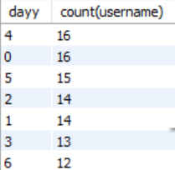

**INVESTOR METRICS:**

1. **User Engagement: This is to know whether the users are still active and post on Instagram or they are making fewer number of posts**



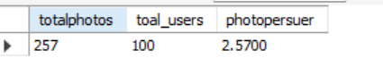

1. **Bots and Fake Accounts: The investor wants to know whether the platform is full with fake and dummy accounts**



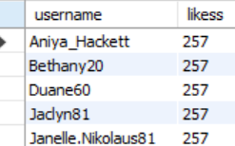

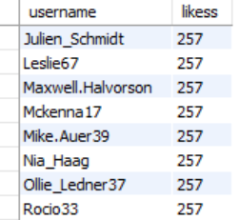

**RESULTS:**

* This gives the fundamentals of data analysis using SQL Queries to extract insights from the database to track how user engage and interact with our platform so that we give proper and insights to the Product, Marketing and Development team

**CONCLUSIONS FROM THE ANALYSIS:**

* User engagement can be very useful matrix for growth of the company
* Marketing team can reward the most loyal customers, send promotional email to the inactive customers, use popular hashtags and find out the best day to do the ad campaign
* Company can remove the fake and dummy accounts from the platform to increase user experience